ASSESSMENT 4

*“SQL JOINS & SQL FUNCTIONS”*



Submitted By

VAIBHAV PATIDAR

IPS ACADEMY, INDORE (M.P.)

**Date :** 07-12-2023

**Week 1** | **Day - 04**

***JOINS IN SQL***

***INNER, RIGHT, LEFT, FULL, NATURAL JOINS***

**Use INNER JOIN to establish relation between employee table and salary table :**

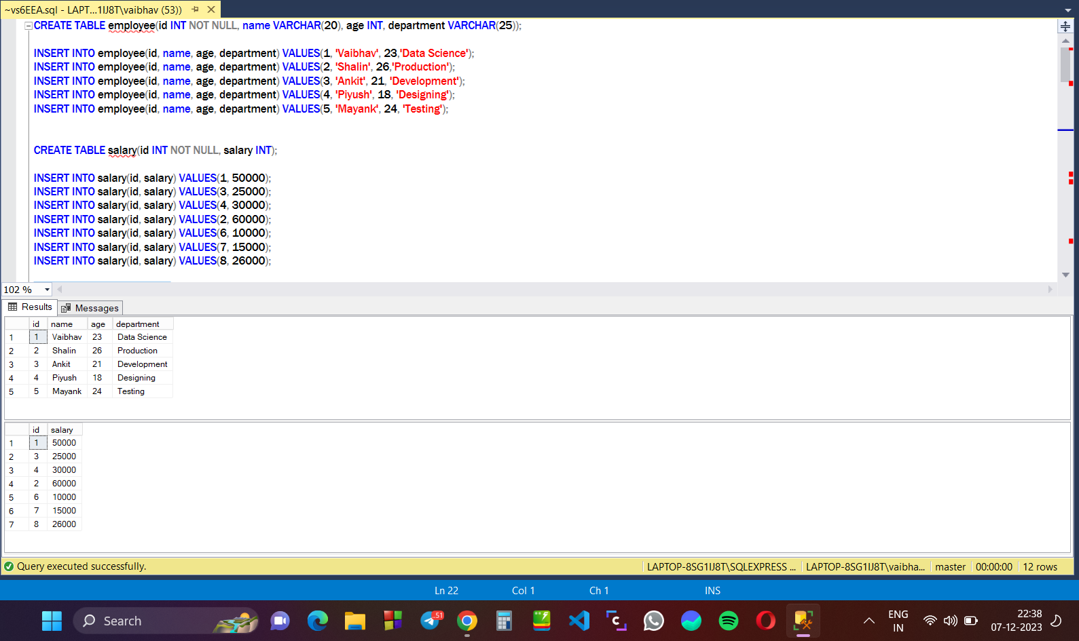

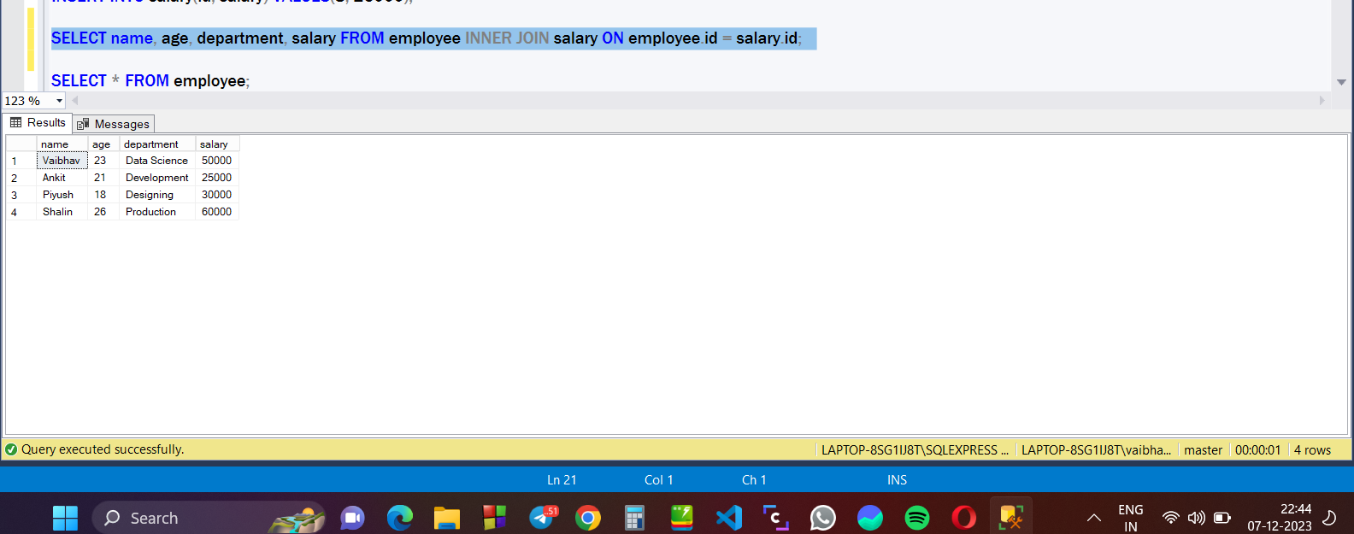

**Use RIGHT JOIN on employee and salary table :**

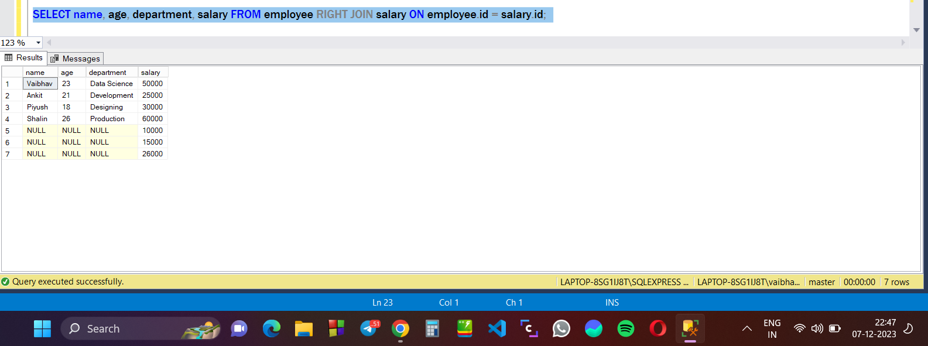

**Use LEFT JOIN on employee table and salary table :**

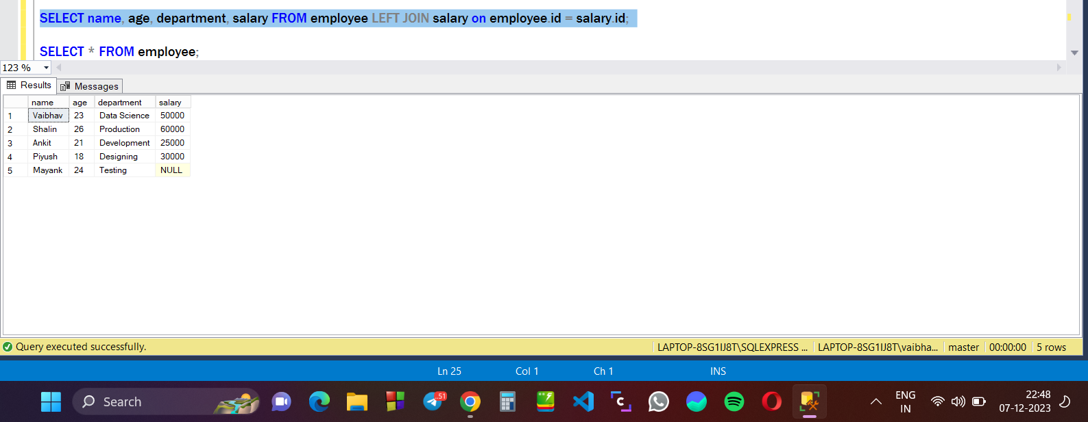

**Use FULL JOIN on employee and Salary table :**

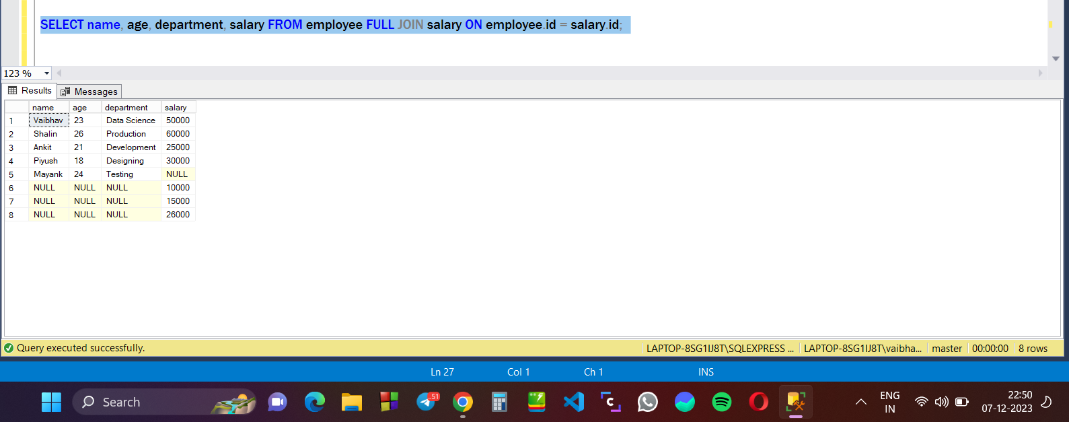

***FUNCTIONS IN SQL***

**There are mainly 9 type of functions :**

1. String Functions
2. Date and Time Functions
3. Mathematical Functions
4. Aggregate Functions
5. Configuration Functions
6. Metadata functions
7. Security Functions
8. System Functions
9. Ranking Functions

**STRING FUNCTIONS : used to manipulate the string values.**

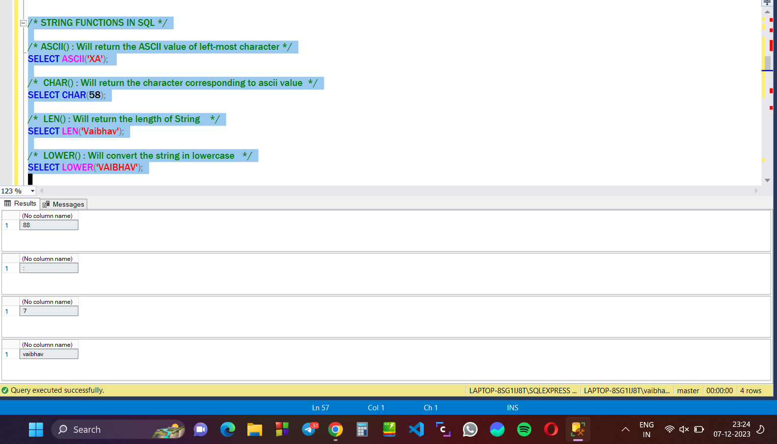

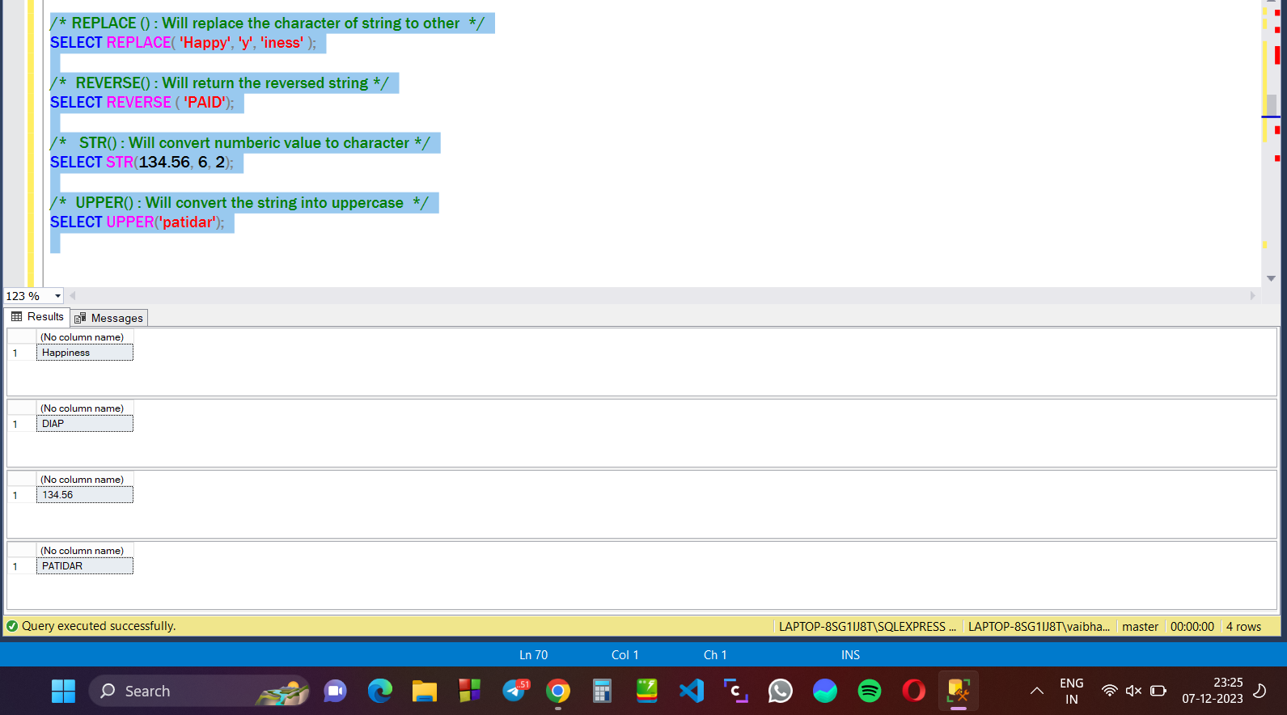

**DATE FUNCTIONS : used to manipulate the date values :**

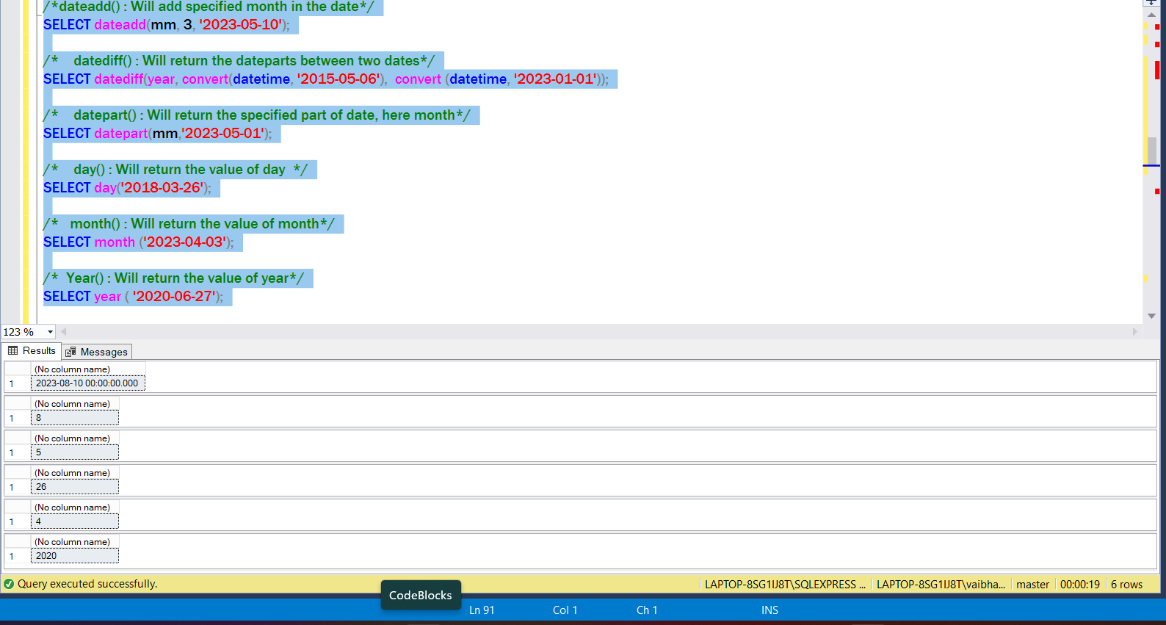

**MATHEMATICAL FUNCTIONS : used to manipulate the numeric values in result :**

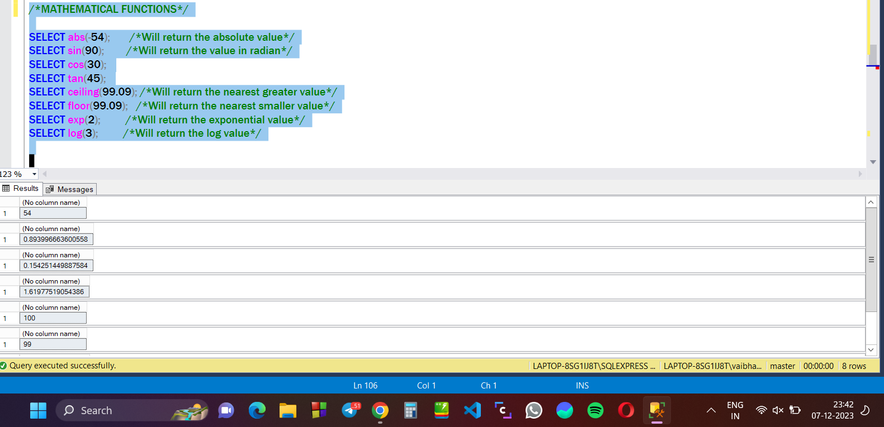

**RANK FUNCTIONS : These functions records and assign ranks in the table :** These functions are used to give rank to the elements in table, and are of three types :

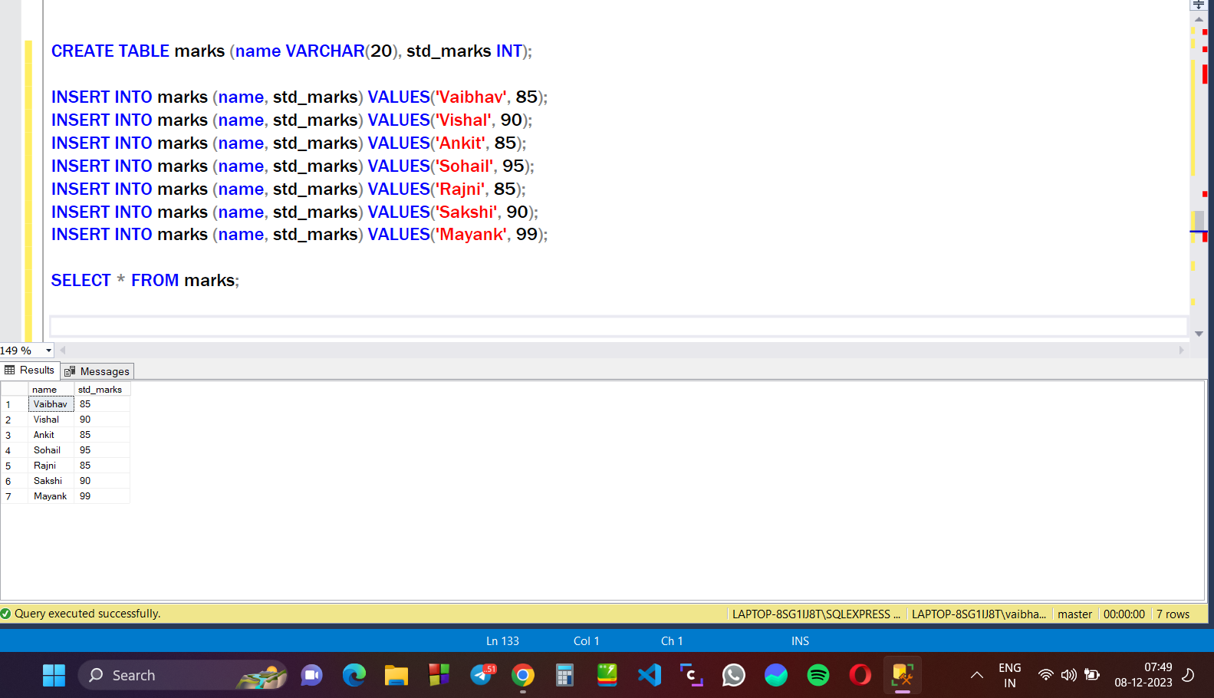

**ROW_NUMBER() :** It will give simple row number to each row of marks table.

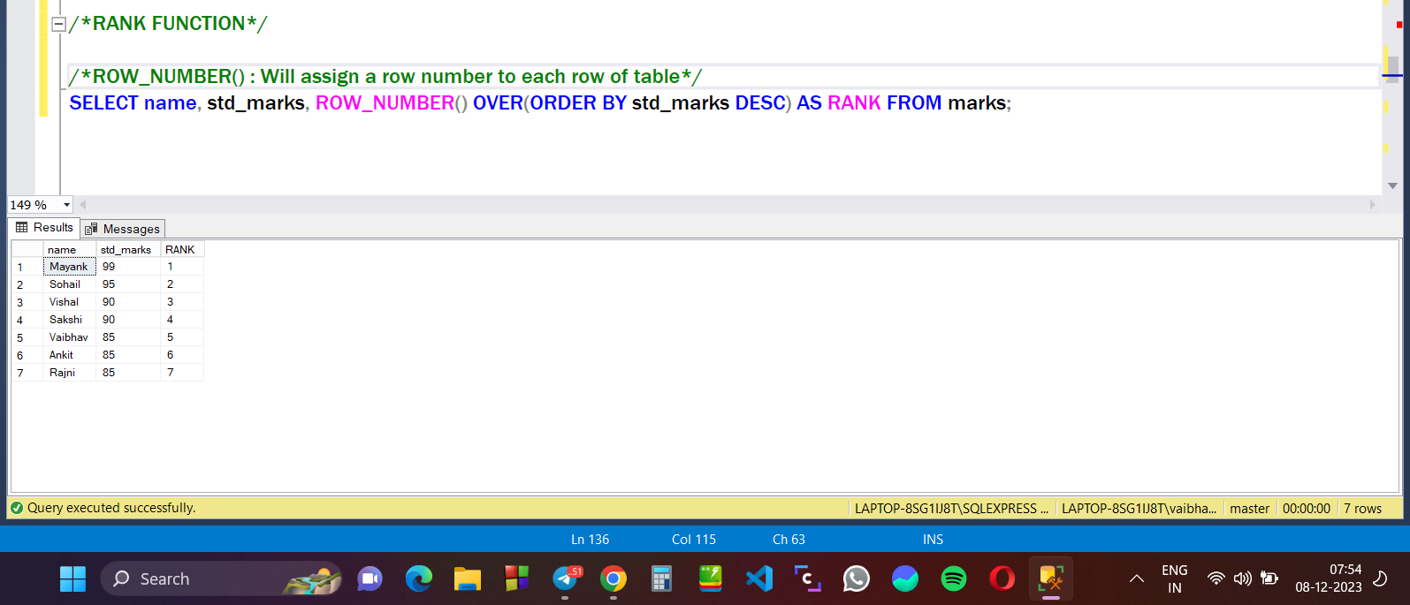

**RANK() :** It will assign same rank to elements having same value and skipped the ranks for rest. Means, if you have 3 items at same rank (i.e. 1), then 4th item will get rank as 4.

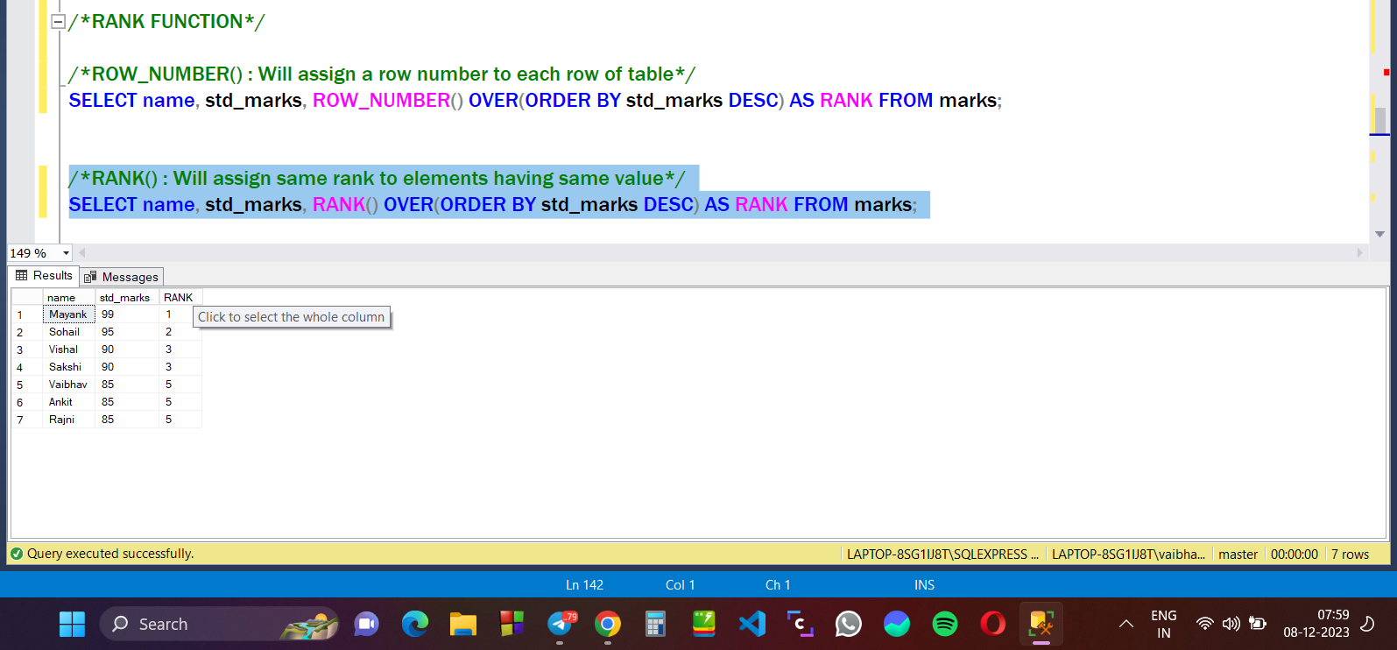

**DENSE_RANK() :** It will assign same rank to each row containing same value, but not skip the rank for next element.

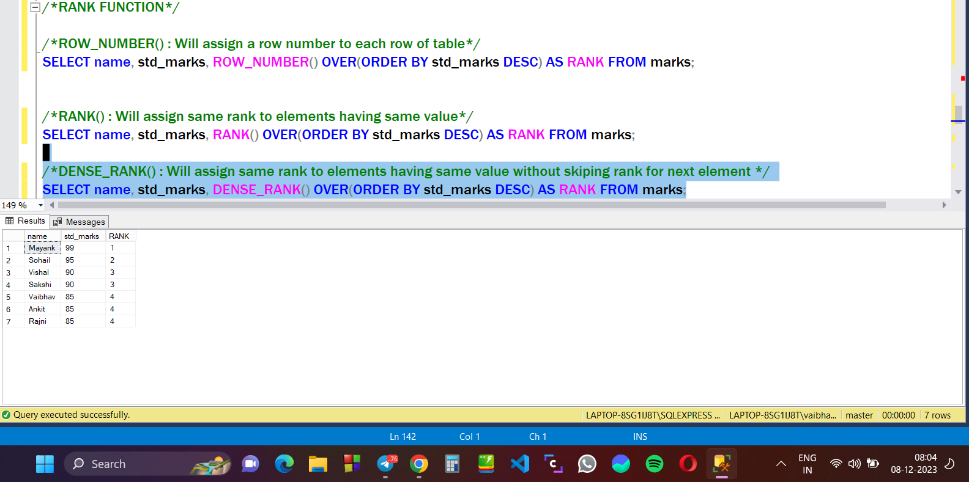

**NTILE(n) FUNCTION :** It will simply divide the table into n groups.

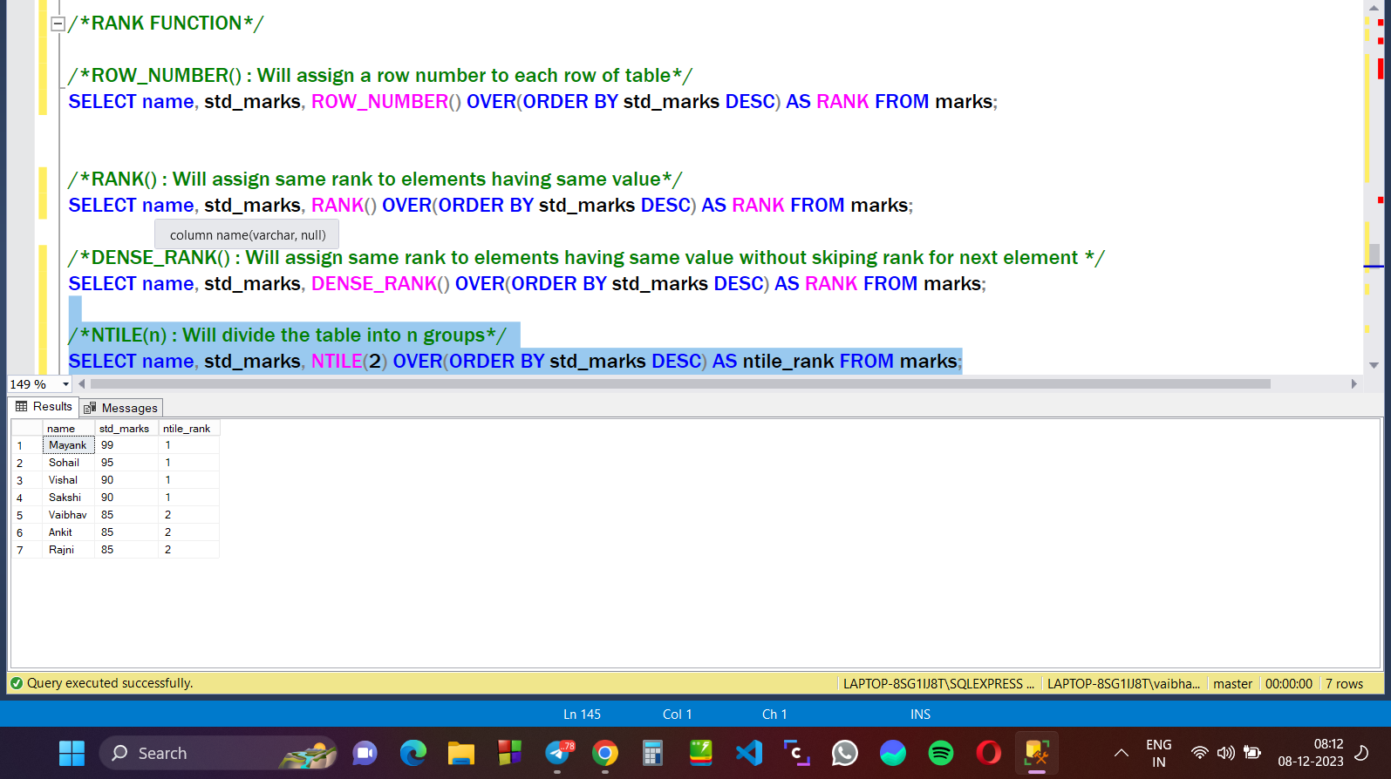

**SYSTEM FUNCTIONS : These functions are used to get info related to our machine :**

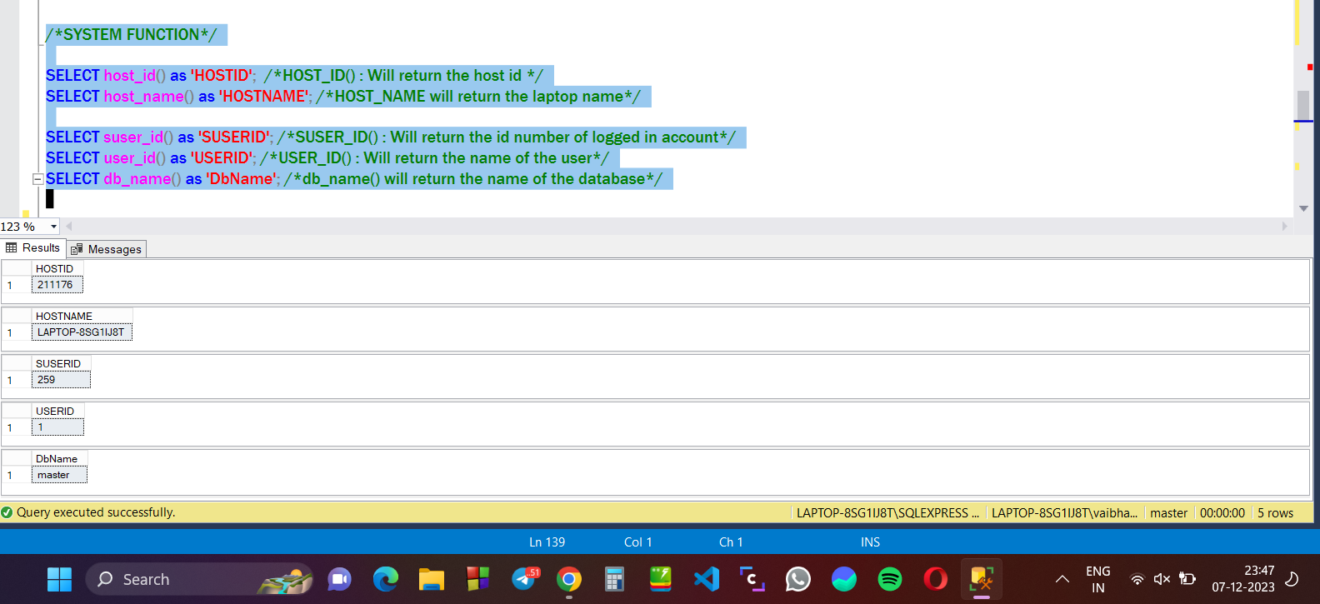

**AGGREGATE FUNCTIONS : These functions helps to analyze the data and provide summarized result :**

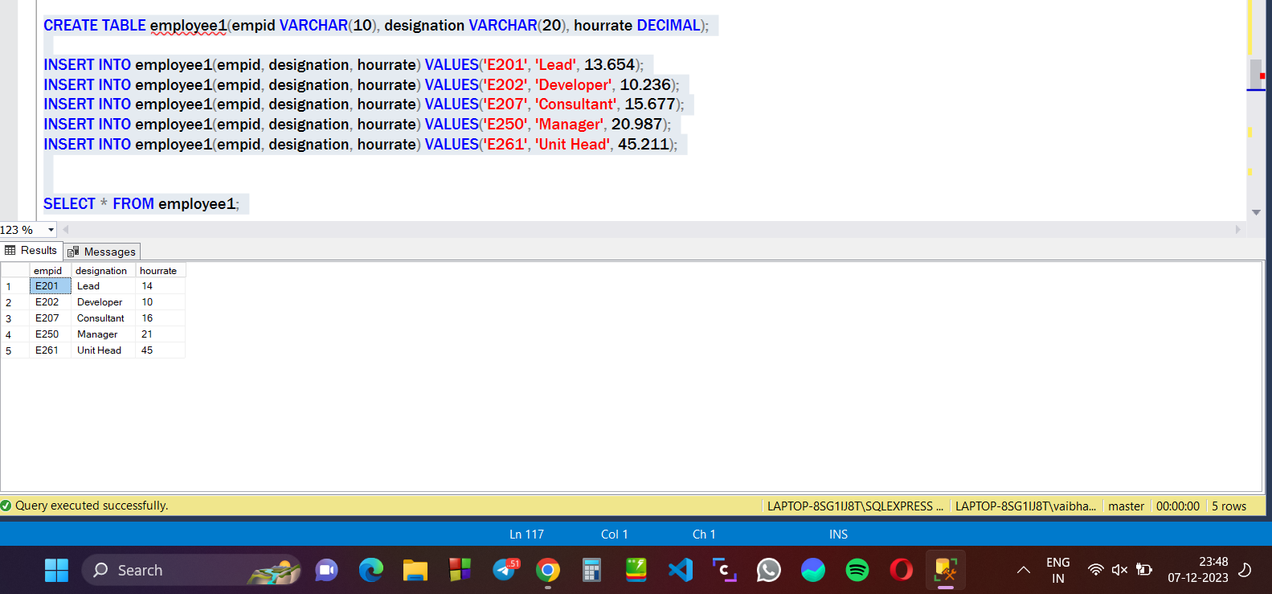

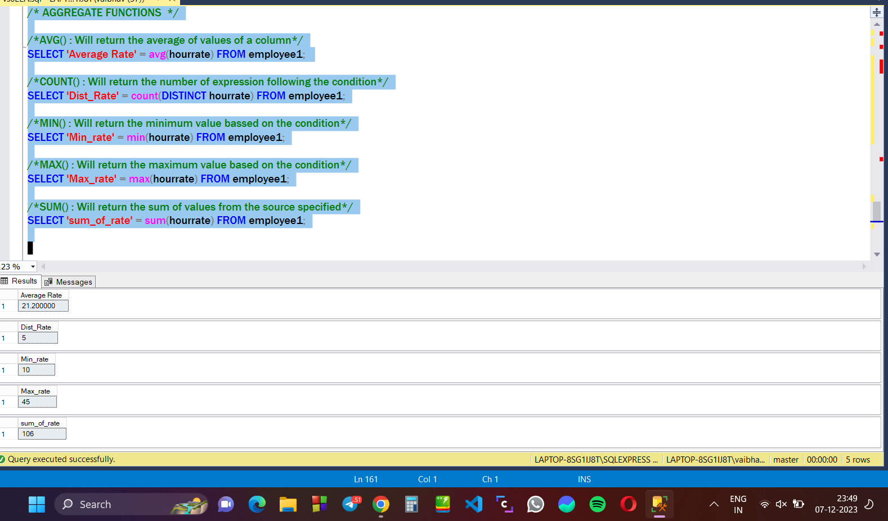

**GROUPING FUNCTIONS :**

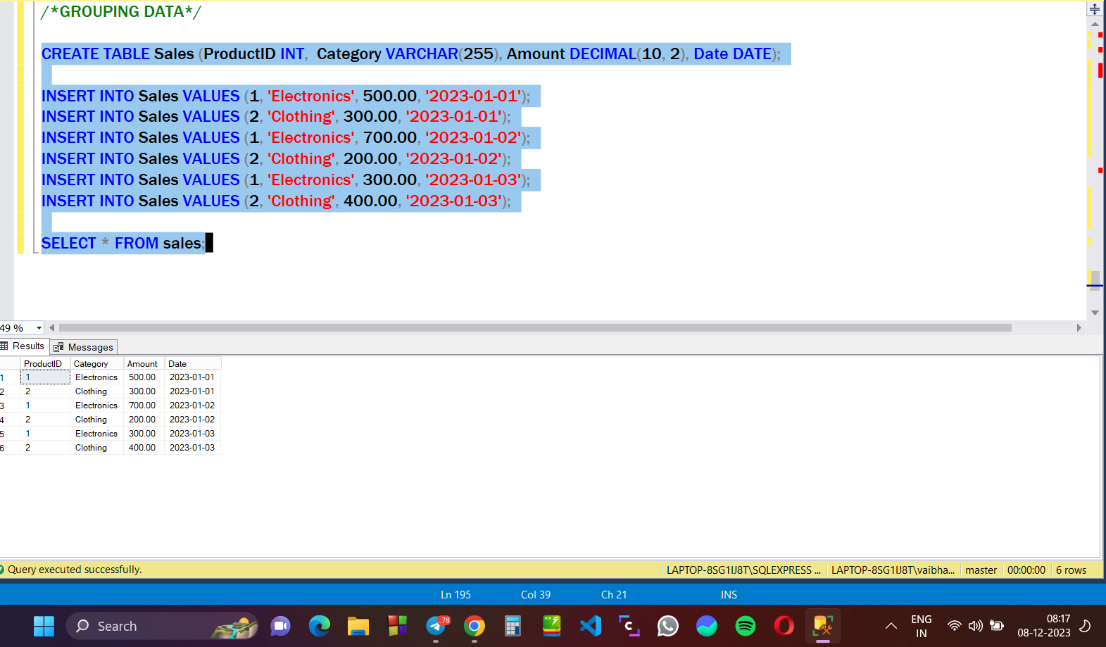

**GROUP_BY FUNCTION() :** It will group the table based on the condition provided.

